omar ahmed elsammak

Movie review classifier

Using BERT model

Hyper parameter tuning (learning rate)

I used 7 learning rates for the processed and unprocessed I used epochs until the model wasn’t learning any moreor the model started to overfit

Then I chose the highest accuracy for the processed and un processed and then evaluated the model using it

**The preprocessed data**:

Graph of train and validation accuracy against the epochs:

Validation accuracy ---> green

Training accuracy --->blue

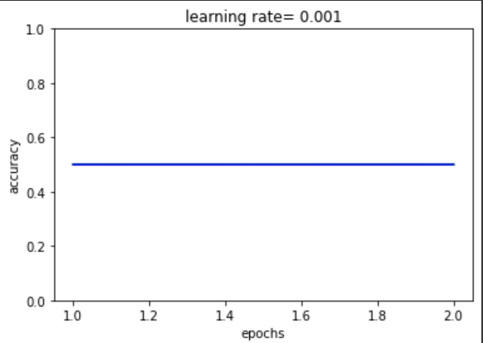

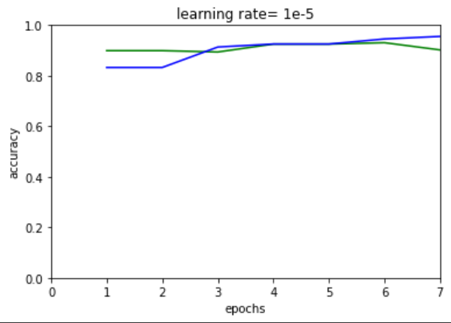

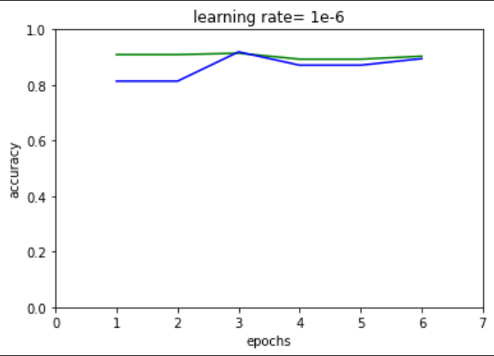

**The original data**:

Graph of train and validation accuracy against the epochs:

Validation accuracy ---> green

Training accuracy --->blue

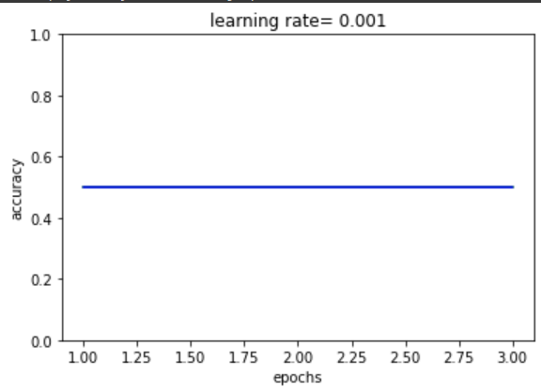

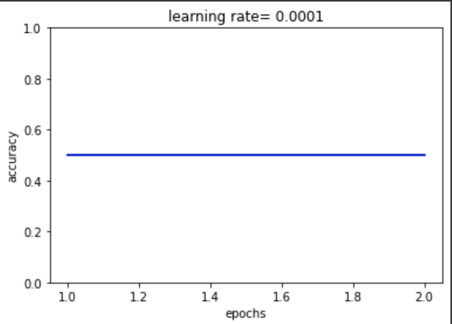

Evaluating the model:

Unprocessed

Processed

Conclusion :

Unprocessed model for data is better because sometimes processing the data may remove the sentence of the meaning